

9B21C028

PRATHAM Institute: SUSTAINING EMPLOYMENT POST-VOCATIONAL TRAINING

Pratyush Banerjee and Tamali Bhattacharyya wrote this case solely to provide material for class discussion. The authors do not intend to illustrate either effective or ineffective handling of a managerial situation. The authors may have disguised certain names and other identifying information to protect confidentiality.

This publication may not be transmitted, photocopied, digitized, or otherwise reproduced in any form or by any means without the permission of the copyright holder. Reproduction of this material is not covered under authorization by any reproduction rights organization. To order copies or request permission to reproduce materials, contact Ivey Publishing, Ivey Business School, Western University, London, Ontario, Canada, N6G 0N1; (t) 519.661.3208; (e) cases@ivey.ca; www.iveycases.com. Our goal is to publish materials of the highest quality; submit any errata to publishcases@ivey.ca. i1v2e5y5pubs

Copyright © 2021, Ivey Business School Foundation Version: 2021-06-23

On April 15, 2020, in a remote corner of India in the town of Pilani, Rajasthan, Sanjay Singh Yadav, head of the Pilani centre of the Pratham Institute for Literacy, Education & Vocational Training (Pratham Institute), was at the institute’s central office, going through a detailed report about the recently concluded vocational training on hospitality and housekeeping for the period 2019−2020. The Pratham Institute had been launched by Pratham, a non-governmental innovative learning organization, and it served as the organization’s vocational skilling arm. The Pilani vocational education training (VET) centre, one of two training centres located in Rajasthan (the other was in Jhalawar), prepared rural youth for careers in the hospitality industry.

In 2019−2020, more than 600 rural youth were trained through Pratham’s centre in Pilani. Yadav was happy about the progress made by the training efforts, but he was troubled by a critical challenge surfacing after the training phase: trainees were quitting their jobs shortly after being placed. Yadav was looking at data on the total number of employment dropouts from the groups that had completed training during 2019−2020. The dropout rate for 2019−2020 stood at 22 per cent, which was higher than it had been in any of the preceding years. Yadav observed that trainee dropout was not happening during the course; rather, most of the participants were quitting their jobs and returning to their home villages shortly after beginning employment. In fact, this had been a constant phenomenon in the country for the past few years.

The rate of trainees dropping out of their jobs after completing their training had been a critical issue for all of Pratham Institute’s training centres in recent times. In fact, this trend had been observed across the entire vocational training landscape of India, and Yadav was left contemplating what could be the reason behind the trend. After all, the program offered trainees good opportunities to establish their careers, which otherwise would have been restricted to farming or menial labour. Yadav wanted to get to the root of the problem.

PRATHAM’S FOOTPRINT IN VOCATIONAL TRAINING IN INDIA

Pratham had been instrumental in educating children from underprivileged segments of society since 1994. The pioneers of the organization, Dr. Madhav Chavan and Farida Lambey, had laid the humble foundations for Pratham in the slums of Mumbai. Gradually, the organization had grown in scope and size, and it now had chapters spread across more than 20 states in India as well as a presence in the United States, the United Kingdom, Germany, Sweden, and Australia. Pratham was one of the largest non-governmental organizations of India in the child education domain and was known for its noteworthy contributions to the development of the lower strata of society.

India had great potential to reap demographic dividends from the huge base of its working adult population in the near future. The United Nations’s *2019 Revision of* *World Population Prospects* report[1] forecasted that, by 2020, India would provide 250 million workers to the world labour pool at a rate of 18 million workers per year. India’s labour market was expected to need 136 million skilled workers in various vocational fields by 2022, according to Aspiring Mind’s 2019 *National Employability Report*.[2]

At the start of the new millennium, the world started noting the demographic dividend possessed by India due to its huge number of employable youths. Government initiatives, such as the National Skill Development Corporation (NSDC), formed in 2009 by the Ministry of Human Resource Development, were established to help in skilling the vastly untapped labour force of India. This was part of the National Skill Development Mission formulated in 2008 in the country’s 11th five-year plan.[3] With India’s labour market needing so many skilled workers in various vocational fields by 2022, NSDC aimed to achieve the vocational skilling of 150 million Indian youth through public−private partnerships by 2022.[4]

Several major corporate players stepped forward with their corporate social responsibility (CSR) initiatives to help upskill the unorganized labour pool. Many public−private partnerships[5] were formed between NSDC and major business firms, including the Aditya Birla Group’s Aditya Birla Skill Foundation and Bharti Enterprise’s Centum. Several private players also entered this space. A report developed by Accenture in association with NSDC listed the Aditya Birla Skill Foundation, Pratham, Gram Tarang, Centum, and EduBridge as some of the major players in this sector.[6] The report highlighted the major progress in the vocational education space and stated that the training centres/units were doing a good job of providing the right infrastructure and proper learning orientation to trainees, with some noteworthy achievements in generating employment.

However, the report also related the concerns of several trainees who were not happy with the career counselling component of the training or the lack of formal post-training support (see Exhibit 2). The report also indicated that the dropout of trainees from employment was a major issue.

The top management of Pratham recognized the need for imparting vocational skill-based education to the young Indian labour force. Thus, in 2005, it formed the Pratham Institute, the vocational training division of Pratham,[7] in partnership with Accenture. Pratham Institute’s VET program was an integral part of Accenture’s “Skills to Succeed” initiative,[8] which engaged primarily in imparting skills pertaining to five key sectors: business process outsourcing, hospitality and facilities management, retail, construction, and micro-enterprise.

Initially, Pratham Institute focused on foundation courses on enhancing youth employability while operating from four non-residential centres in Maharashtra. By 2007, around 25,000 youth had participated in the employability foundation courses offered by Pratham Institute. In 2008, the first construction site for in-house programs was commenced in Latur, Maharashtra. The first hospitality training centre was set up in Aurangabad in August 2009. Around this time, Pratham Institute started expanding the scope of its vocational training. Along with hospitality training, it commenced courses on automotive maintenance in 2010, and electrical technician training in 2011; in 2011, it also opened a health care training centre, and in 2012, it opened a beauty training centre. By 2017, Pratham Institute had expanded its footfall in 16 states and had trained over 100,000 youth in industry-specific and other vocational skills (see Exhibit 1 for a detailed timeline). In 2016−2017 alone, more than 6,000 youth were trained in food and beverage skills, over 3,500 were trained as general duty assistants, over 2,000 were trained as automotive technicians, over 4,000 were trained as electricians, and about 2,000 were trained as beauticians (see Exhibit 4). Most of these trainees received placement support from Pratham Institute, with an average of 80 per cent of the trainees who had successfully completed the program placed in employment. In the food and beverage sector, the placement rate was 95 per cent, indicating the scope and opportunity of employment in this sector.

The overall value of the tourism and hospitality sector of India was expected to reach US$418.9 billion by 2022.[9] The travel and tourism sector in India accounted for 8 per cent of the total employment opportunities generated in the country in Financial year 2020 alone, creating employment to around 39 million people that year[10]. This number is going to rise to 53 million jobs by 2028.[11] In Rajasthan alone, the hospitality sector accounted for 15 per cent of the state’s economy, and almost 7 per cent of the state’s total employment.[12]

Pratham’s vocational training initiative held a great deal of promise for employment generation for Indian youth, and it could help India realize its hope of cashing in on its demographic dividend. Much effort was being put into making the trainees ready for the job market at Pratham Institute’s training centres. However, despite all of this effort and the provision of job opportunities to the underemployed youth of India, several cases of trainees quitting their jobs prematurely were reported by employers (see Exhibit 2). Yadav therefore felt the need to understand the reason behind trainees voluntarily leaving their jobs.

PRATHAM’S VOCATIONAL TRAINING FRAMEWORK

Pratham Institute’s Pilani centre was located within the Pilani Resource Center, which was an outreach initiative of the Birla Institute of Technology and Science’s Alumni Association. The centre operated from the first and second floors of this three-storied structure. The administrative office was on the first floor, along with rooms dedicated to basic computer skill training, theoretical classes, and role-playing sessions. The second floor housed a fully equipped dining hall with all the necessary paraphernalia for conducting simulated training for food and beverage serving for different settings like a-la-carte dining and buffet serving, and a simulated double-bed hotel room for housekeeping training. In addition to these facilities, the centre also provided lodging to the trainees free of cost. The entire set-up was sponsored by Accenture as part of its CSR initiative. The centre was run by an eight-member team (five trainers and three managers). The centre ran hospitality training courses that included catering and housekeeping. These were two-month residential courses completely sponsored by Accenture. The maximum intake capacity was 3,000 students a year, in multiple cohorts. The course intake at the Pilani VET centre was between 25 and 30 candidates per cohort. The centre conducted two such cohorts in parallel.

Regarding the course structure, Pratham had signed a memorandum of understanding with Taj Hotels[13] to oversee the curriculum and provide input on how to train the candidates. Several corporate houses came forward to aid in this novel initiative. For example, in the Jhalawar district of Rajasthan, ITC Ltd. sponsored 300 trainees for the hospitality training course. Pratham Institute followed a four-step process to reach out to potential trainees from the rural hinterlands of India (see Exhibit 3).

**Step 1: Community Outreach⎯**The biggest challenge Pratham faced in the process of conducting vocational training was unfamiliarity among the rural people of India regarding such initiatives. The Indian economy was traditionally dependent on agriculture and farming. It was thus very difficult to convince people accustomed to such a way of life about the benefit of letting their children enroll in vocational training. Many parents were reluctant to let their children leave home in search of a livelihood. In order to change such perceptions, Pratham deployed teams of two to four members to remote villages and districts to conduct community outreach programs. Pratham used this opportunity to give villagers an understanding of the value of letting their children join such courses by offering workshops and talks on career counselling. The team addressed all queries and apprehensions regarding accommodation and job opportunities. References from Pratham Institute alumni from nearby regions were shared in order to encourage parents to seek the counsel of such individuals, who could convince them to allow their children to join the program. Placement statistics were also shared, to give the villagers an idea of the economic value addition that could result from completion of the training. This step was crucial, since this was the time when potential trainees typically made up their minds to join the program.

**Step 2: Skilling the Trainees⎯**Pratham Institute’s VET centres ran training programs in various vocational disciplines following curriculum developed by NSDC. The Pilani centre ran two training courses: one on food and beverage skills and the other on housekeeping skills.

The two programs consisted of a balanced combination of theoretical and practical aspects. The pedagogy for the food and beverage course encompassed lecture sessions imparting knowledge about tableware and cutlery items, practical demonstrations, and role-playing exercises (see Exhibits 5, 6, and 7). The housekeeping course oriented trainees on the working mechanisms of various types of cleaning equipment, procedures for cleaning rooms, and methods for handling a chambermaid trolley. Trainers gave live demonstrations on preparation of hotel beds for customers, towel decoration techniques, and bathroom cleaning procedures (see Exhibits 8 and 9). A great deal of emphasis was put on self-learning through reading materials and on audio-visual learning through specially designed online content to reinforce the learning of students, who were able to access the simulation through the centre’s computers or with the help of a tablet provided by Pratham Institute during training. Regular group discussions and peer evaluations took place to ensure that everyone learned the details of the skills. Apart from the vocational skills, basic communication skills and computer literacy skills were also imparted to students. Industry visits were arranged at nearby heritage hotels to give the students a feel for their future work setting (see Exhibit 8).

**Step 3: Placement⎯**The Pilani centre could support and had capacity for upskilling up to 1,000 students every year. However, the centre struggled to utilize its intake capacity to the fullest. For instance, in 2018, about 500 students were trained by the centre, out of which 350 were placed. All trainees were provided internships at the end of the course. The average salary ranged from ₹6,000 to ₹8,000[14] apart from food and lodging during the internship. On completion of the internship, students were usually absorbed by those hotels. Beginning full-time employment, their salaries ranged between ₹9,000 and ₹12,000, and they continued to receive food and accommodation for free. Some of the major recruiters of Pratham Institute’s VET centres were Taj Hotels; Lemon Tree Hotels; The Leela Palaces, Hotels and Resorts; ITC Hotels; and several five-star boutique and heritage hotels located in Udaipur and Jaipur. Yadav was proud to mention that about 60 students had secured placements at various foreign locations. Students were also encouraged to follow an entrepreneurial route. Yadav shared that 35 alumni had opened their own hotels after gaining enough exposure in the hotel industry.

**Step 4: Job Retention and Upskilling⎯**This was another important focus area for Pratham Institute, as it wanted to prevent trainees quitting their jobs after securing placement. However, every year, about 20 per cent of placed students left their jobs within a short period of joining their employers. To address this issue, Pratham Institute came up with several initiatives. One was to facilitate an onboarding process for the trainees by helping them open bank accounts, issuing them permanent account number (PAN)[15] cards and Aadhar[16] card documents, and so on. This way, Pratham Institute ensured that the trainees did not feel unsettled or overwhelmed by the joining formalities and could settle down in their professional roles without much hassle. Another novel initiative undertaken by Pratham Institute to help in the retention of trainees was the creation of an alumni association, called the Pratham Alumni Linkage (PAL) Network. PAL Networks had a presence in over 20 cities in India and served as a counselling support system in the case that newly placed trainees felt out of place at their jobs. The networks could help trainees reach out to alumni who were stationed close to their location and thereby connect to a social support network. That way, the trainees could feel more secure in their work environments. Other notable initiatives taken by Pratham Institute to ensure trainees did not leave their jobs included a 12-month tracking network, which kept track of any difficulties faced by the trainees and accordingly intervened to resolve such problems. Pratham Institute also provided migration support hostels for accommodating trainees who were economically disadvantaged, making their initial transition to urban life less challenging.

CHALLENGES OF JOB RETENTION AFTER COMPLETION OF TRAINING

The contribution of Pratham Institute’s VET centres towards skilling rural youth and making them employable for the job market could indeed be considered praiseworthy. The curriculum followed by the centres for training youths was highly industry-relevant and validated by experts. The centres’ trainers had themselves been trained by industry experts and in-house mentors and could thus impart the pertinent knowledge to trainees. The level of dedication of the trainers and the rigour of the training at the Pilani centre was apparent in role-play sessions at the centre.[17] Yet, despite all of Pratham Institute’s efforts to sensitize the trainees towards the demands of their job roles, a steady exodus of students from their jobs continued to happen, typically not long after the trainees joined the industry. Approximately 20,000 students had completed hospitality training from the various VET centres across 16 states in India by April 2020. According to data shared by Pratham management, about 80 per cent of all trainees (roughly 16,000) were placed in jobs upon completion of the course (see Exhibits 2 and 3). Eighty per cent of these trainees continued with the jobs six months after joining, while the remaining 20 per cent quit their jobs and went back to their families. This statistic indicated that almost 3,000 trainees were not able to sustain their employment facilitated through Pratham Institute’s VET centres. This was a serious waste of effort and money on the part of both Pratham and its corporate stakeholders. This trend could be a critical setback with respect to the grand dream of achieving India’s demographic dividend and enhancing the employability of rural Indian youth. In fact, these findings had been observed in Accenture’s report,[18] which highlighted the problem of trainees dropping out as a major roadblock on the path towards achieving India’s ambitious youth-skilling initiative. The Accenture survey (carried out in partnership with NSDC) was conducted with more than 2,000 trainees who had completed their training from NSDC’s various vocational training partners. The study revealed that post-placement support systems were lacking, leading trainees to feel disillusioned with their jobs very early on. Almost 50 per cent of cases where trainees quit had happened because of this type of expectation mismatch. One critical finding from the survey was that trainees found it difficult to cope with urban environments and left their jobs due to apprehension over not being able to sustain themselves in these environments. There was also the issue of less participation by women in this vocational skilling movement. Motivating women to take the step and join such programs remained a major concern for all VET stakeholders (see Exhibit 9).

Yadav perceived that some intervention in the above issues needed to be implemented urgently to stop the undesirable phenomenon of trainee dropout from employment. Pratham had already initiated the PAL Network program, and through some counselling sessions and guest lectures, it also tried to help students understand the long-term economic benefit of staying in their jobs He wondered what else could be done to tackle the problem in a more structured manner.

EXHIBIT 1: A CHRONOLOGICAL DEPICTION OF PRATHAM’S JOURNEY

|  |  |  |
| --- | --- | --- |
| Pratham’s History in Vocational Education | | |
| Year | **Event** | **Locations/Outreach** |
| 2005 | Four Non-Residential Centres opened | Mumbai, Maharashtra |
| 2008 | First Construction Training Centre in Latur, India | Latur, Maharashtra |
| 2009 | First Hospitality Training Centre in Aurangabad, India | Latur and Aurangabad, Maharashtra |
| 2010 | First Automotive Training Centre in Nandurbar, India | Latur, Aurangabad, and Nandurbar, Maharashtra |
| 2011 | First Health Care Training Centre in Latur, India  First Electrical Training Centre in Ahmednagar, India | Latur, Aurangabad, Ahmednagar, and Nandurbar, Maharashtra |
| 2012 | First Beautician Training Centre in Assam, India | Maharashtra and Assam |
| 2017 | Between 2012 and 2017, Pratham’s operations expanded to 16 states in India, and over 100,000 youth received training at its various centres; of these individuals, over 75,000 were trained in vocational skills. | |

Source: Company files.

EXHIBIT 2: PRATHAM’S COURSE-WISE IMPACT ON CREATING EMPLOYABILITY ACROSS INDIA

| **Pratham’s Impact on Generating Employment for Indian Youth** | | | |
| --- | --- | --- | --- |
| **Reaching the Unreached** | | | |
| - By April 2020, T 75,000 youth have been trained in industry-specific skills.  - In 2017 alone, Pratham trained 25,000 youth. | | | |
| **Demographic Profile of Trainees** | | | |
| - 40% women  - 50% from lower economic classes | | | |
| **Employment Impact** | | | |
| - 80% of the trainees receive employment.  - Family income increases from ₹3,500 per month to ₹10,000 per month.  - 25% increase in salary after six months of probation | | | |
| **Problem Area⎯Dropout of Trainees in Employment after being Placed by Pratham’s Pilani Centre** | | | |
| **2015−2016** | **2016−2017** | **2017−2018** | **2018−2019** |
| 47 out of 130 | 58 out of 165 | 92 out of 325 | 85 out of 350 |
| **Initiatives Taken for Retaining Trainees Placed in Employment** | | | |
| Support was given through the issuance of such things as a PAN card, Aadhar (identity number), and a bank account, as well as connecting trainees with alumni through PAL Networks. | | | |

Note: ₹ = INR = Indian rupees; US$ 1 = ₹75.72 on April 30, 2020. PAN = permanent account number; PAL = Pratham Alumni Linkage.

Source: Company report.

EXHIBIT 3: PRATHAM’S FOUR-STEP STUDENT ENGAGEMENT PROCESS

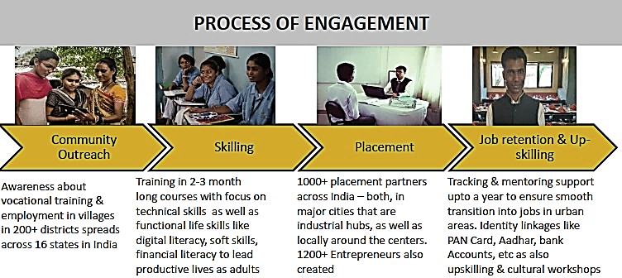

Note: PAN = permanent account number.

Source: 2016−17 Company report, shared by Pratham management.

EXHIBIT 4: PRATHAM’S PAN-INDIA IMPACT ON CREATING EMPLOYABILITY

| **Programs** | Hospitality | Health Care | Automotive | Electrical | Beauty | Construction |
| --- | --- | --- | --- | --- | --- | --- |
| **Courses** | Food & Beverage | General Duty Assistant | 2/3/4-Wheeler Automotive Technician | Assistant Electrician | Assistant Beauty Therapist | Mason Bar Bending, Welding |
| Housekeeping |
| Food Production |
| **Trained in 2016−2017** | 6,200+ | 3,500+ | 2,000+ | 4,000+ | 2,000+ | 1,200+ |
| **Placement** | 95% | 80% | 80% | 80% | 75% | 80% |

Source: Company report, shared by Pratham management.

EXHIBIT 5: STUDENTS LEARNING TO MIX A MARTINI (EXPERIENTIAL TRAINING)

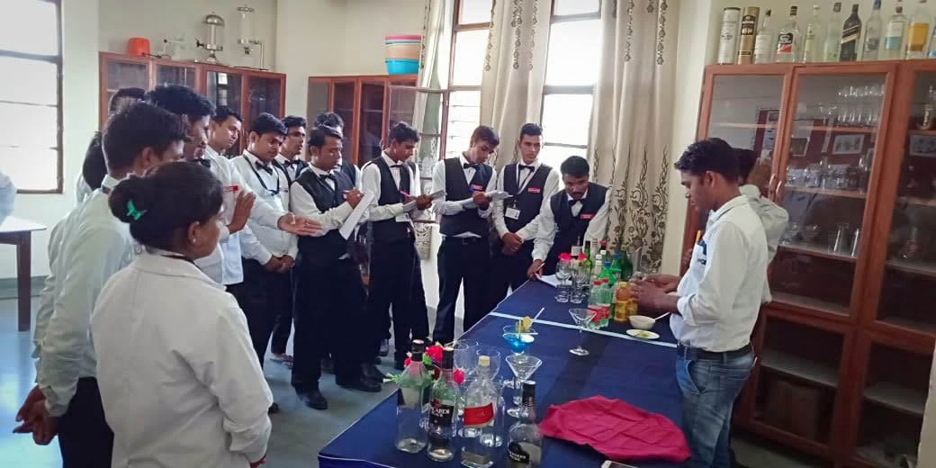

Source: Company files.

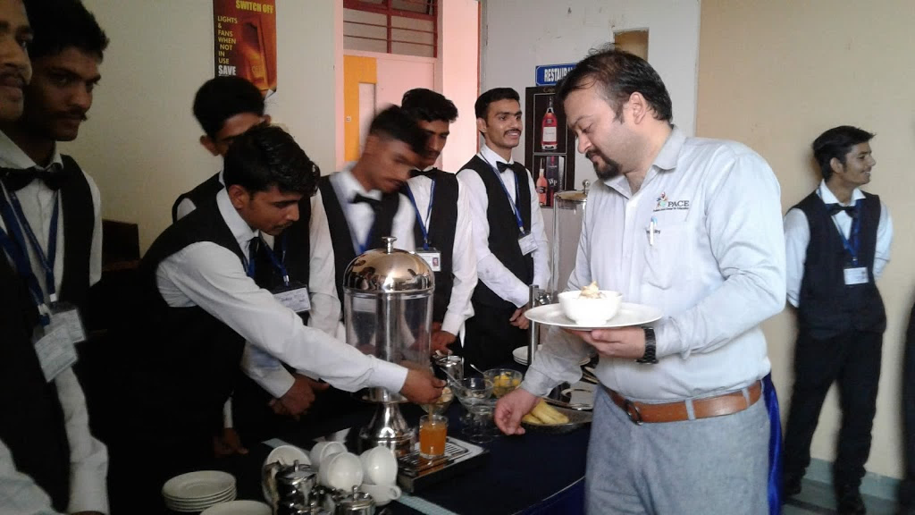EXHIBIT 6: STUDENTS TAKING PART IN ROLE-PLAY EXERCISES

Note: One of Pratham Institute’s trainers playing the role of a hotel guest in this picture.

Source: Company files.

EXHIBIT 7: HOUSEKEEPING TRAINING CONDUCTED THROUGH EXPERIENTIAL LEARNING

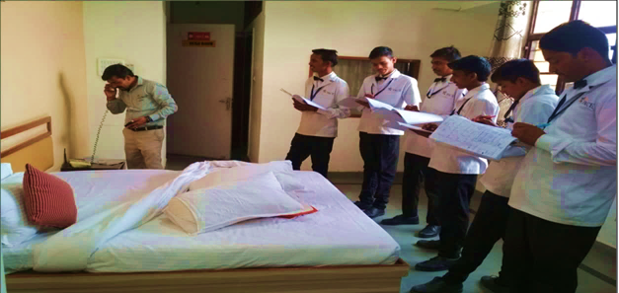

Source: Company files.

EXHIBIT 8: INTERNSHIPS AND INDUSTRIAL VISITS

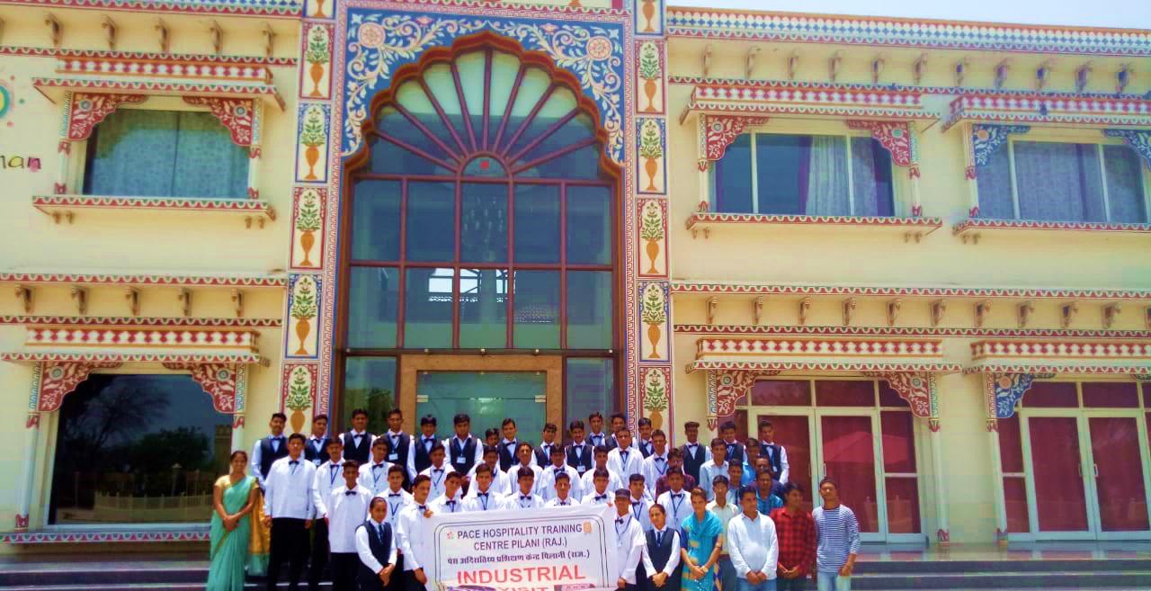

Source: Company files.

EXHIBIT 9: Pratham INSTITUTE trainees after successful completion of food and beverage training

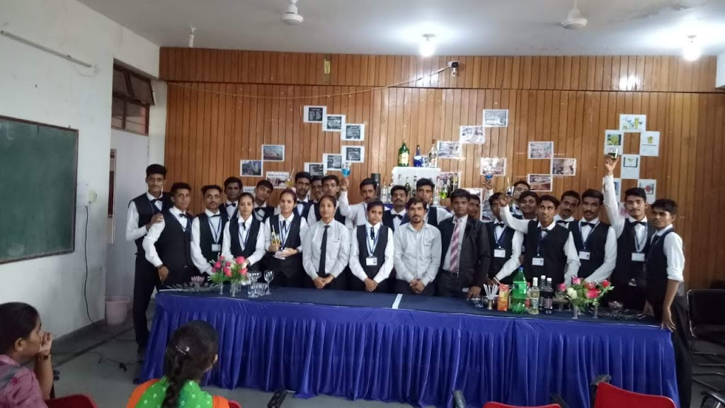

Source: Company files.

1. United Nations, Department of Economic and Social Affairs, *2019 Revision of* *World Population Prospects*, 2019, <http://esa.un.org/wpp/Excel-Data/population.html>.
2. Aspiring Minds, *National Employability Report*, SHL, 2019, accessed on August 17, 2020, <https://www.aspiringminds.com/research-reports/national-employability-report-for-engineers-2019/>.
3. Shailaja Tripathi, “NSDC Partners with TCS to Promote Skill Development,” Jagranjosh, June 10, 2020, accessed on July 3, 2020, <https://www.jagranjosh.com/current-affairs/nsdc-partners-with-tcs-to-promote-skill-development-1591777638-1>.
4. Confederation of Indian Industry, *India Skills Report 2015*, November 10, 2014, accessed on July 16, 2020, [www.cii.in/PublicationDetail.aspx?enc=KZoB+auhgWWBFkUHBCzsvXarpynXeu7QomtMCmJbvcc=](http://www.cii.in/PublicationDetail.aspx?enc=KZoB+auhgWWBFkUHBCzsvXarpynXeu7QomtMCmJbvcc=).
5. Priyaranjan Jha, “PPPs Could Show the Way for Employment Generation in India,” *Economic Times*, April 26, 2019, accessed May 15, 2020,

   <https://economictimes.indiatimes.com/jobs/view-ppps-could-show-the-way-for-employment-generation-in-india/articleshow/69048699.cms?utm_source=contentofinterest&utm_medium=text&utm_campaign=cppst>.
6. Accenture, *Overcoming India’s Skills Challenge: Transforming India into a High-Performance Nation*, 2013, Criticaleye, accessed on June 9, 2020, <https://www.criticaleye.com/inspiring/insights-servfile.cfm?id=3957>.
7. “Vocational Training,” Pratham, accessed on August 10, 2020, <https://www.pratham.org/programs/vocational-training/>.
8. Accenture, *Skills to Succeed: India* (n.p.: Accenture, n.d.), accessed on May 31, 2020, <https://www.accenture.com/in-en/company-citizenship-skills-to-succeed>.
9. PTI, “India’s Tourism Potential Needs to be Tapped: Economic Survey,” *Economic Times*, August 11, 2017, accessed on June 22, 2020, [https://economictimes.indiatimes.com/magazines/travel/indias-tourism-potential-needs-to-be-tapped-economic-survey/articleshow/60023593.cms?utm_source=contentofinterest&utm_medium=text&utm_campaign=cppst](https://economictimes.indiatimes.com/https://economictimes.indiatimes.com/magazines/travel/indias-tourism-potential-needs-to-be-tapped-economic-survey/articleshow/60023593.cms?utm_source=contentofinterest&utm_medium=text&utm_campaign=cppst).
10. Contribution of Tourism in Rajasthan economy, accessed on July 1, 2020, https://www.rajras.in/rajasthan-tourism-contribution-economy/.
11. Rajguru Tandon 2018. India to add 10 Million Travel and Tourism jobs in a decade. Accessed on 22 June 2021, http://www.businessworld.in/article/India-To-Add-10-Million-Travel-And-Tourism-Jobs-In-A-Decade-/22-03-2018-144267/.
12. Contribution of Tourism in Rajasthan economy, accessed on July 1, 2020, https://www.rajras.in/rajasthan-tourism-contribution-economy/.
13. Vijay Pinjarkar, “New Center to Give Hospitality Industry Training, Assured Jobs to Pench Youths,” *Times of India*, August 12, 2016, accessed on July 15, 2020, <http://timesofindia.indiatimes.com/articleshow/53659776.cms?utm_source=contentofinterest&utm_medium=text&utm_campaign=cppst>.
14. ₹ = INR = Indian rupee; US$ 1 = ₹75.72 on April 30, 2020.
15. A PAN was an identification number assigned to all taxpayers in India.
16. Aadhar was a unique identity number that could be obtained by residents or passport holders of India.
17. This was the case authors’ observation while attending a role-play session at the Pilani centre.
18. Accenture, op. cit.